# **IDANÄS Bed frame, dark brown stained**

**Product details $1100**

The bed has a strong and sturdy construction that allows you to use it for many years.

Read More

**Materials & care**

* **Mid beam:** Galvanized steel
* **Headboard leg/ Top headboard rail/ Spindle/ Middle headboard rail/ Footboard leg/ Top footboard rail/ Top side rail:** Solid pine, Stain, Clear acrylic lacquer
* **Headboard/ Footboard:** Particleboard, Beech veneer, Stain, Clear acrylic lacquer, Beech veneer, Stain, Clear acrylic lacquer
* **Bedside:** Solid pine, Stain, Clear acrylic lacquer, Stain, Clear acrylic lacquer
* Wipe clean with a cloth dampened in a mild cleaner. Wipe dry with a clean cloth.

## Product size

**Length:**

207 cm (81 1/2 ")

**Width:**

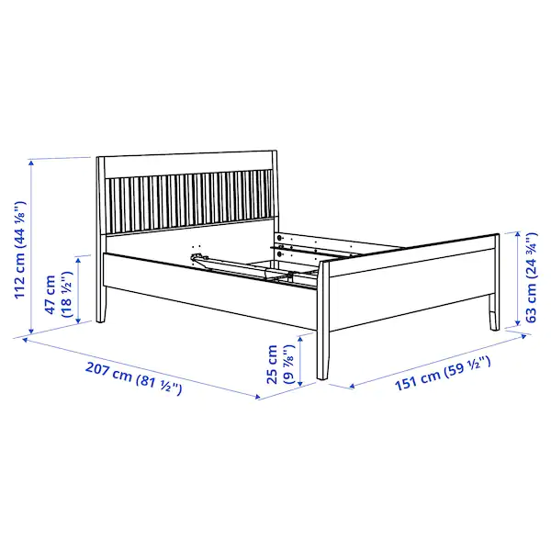151 cm (59 1/2 ")

**Footboard height:**

63 cm (24 3/4 ")

**Headboard height:**

112 cm (44 1/8 ")

**Free height under furniture:**

25 cm (9 7/8 ")

**Mattress length:**

200 cm (78 3/4 ")

**Mattress width:**

140 cm (55 1/8 ")